**DAILY ONLINE ACTIVITIES SUMMARY**

|  |  |  |  |  |  |  |  |
| --- | --- | --- | --- | --- | --- | --- | --- |
| **Date:** | **03/06/2020** | | | | **Name:** | **Anusha. K** | |
| **Sem & Sec** | **4th SEM 'A' Section** | | | | **USN:** | **4AL18CS009** | |
| **Online Test Summary** | | | | | | | |
| **Subject** | | **Object oriented concepts** | | | | | |
| **Max. Marks** | | **30** | | **Score** | | **23** | |
| **Certification Course Summary** | | | | | | | |
| **Course** | **Data visualization using python** | | | | | | |
| **Certificate Provider** | | | **greatlearning academy** | **Duration** | | | **3.5 hours** |
| **Coding Challenges** | | | | | | | |
| **Problem statement 1:**Write a code segment in java to swap two numbers using call by object reference.  **Problem statement 2:**Write a Java program to find Last Digit of a^b (a to the power b) for Large Numbers. | | | | | | | |
| **Status: completed** | | | | | | | |
| **Uploaded the report in Github** | | | | **yes** | | | |
| **If yes Repository name** | | | | [**https://github.com/anusha20219/Lockdown-coding**](https://github.com/anusha20219/Lockdown-coding) | | | |
| **Uploaded the report in slack** | | | | **yes** | | | |

ONLINE TEST DETAILS: OOC test was scheduled from 09:15 am to 10:00am .The portion for the IA was 2nd and 3rd module there were 30 questions and the time assigned was 40 minutes the questions were mcq type.

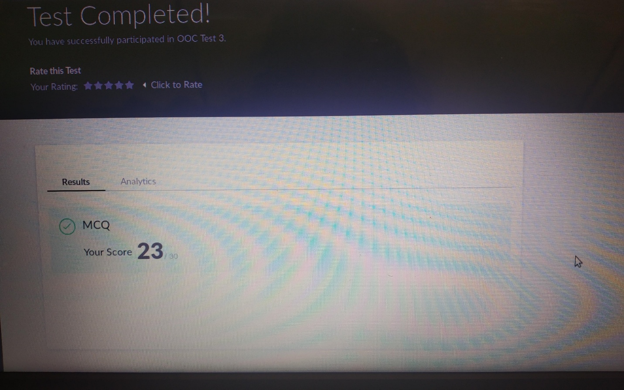

CERTIFICATION COURSE DETAILS: **concepts studied are:**

Seaborn for data visualization

Univariate analysis – Dist plot, count plot, Boxplot, Bar chart

Bivariate analysis – Pair plot, Reg plot, Joint plot, Point plot, Factor plot, Strip plot, Swarm plot

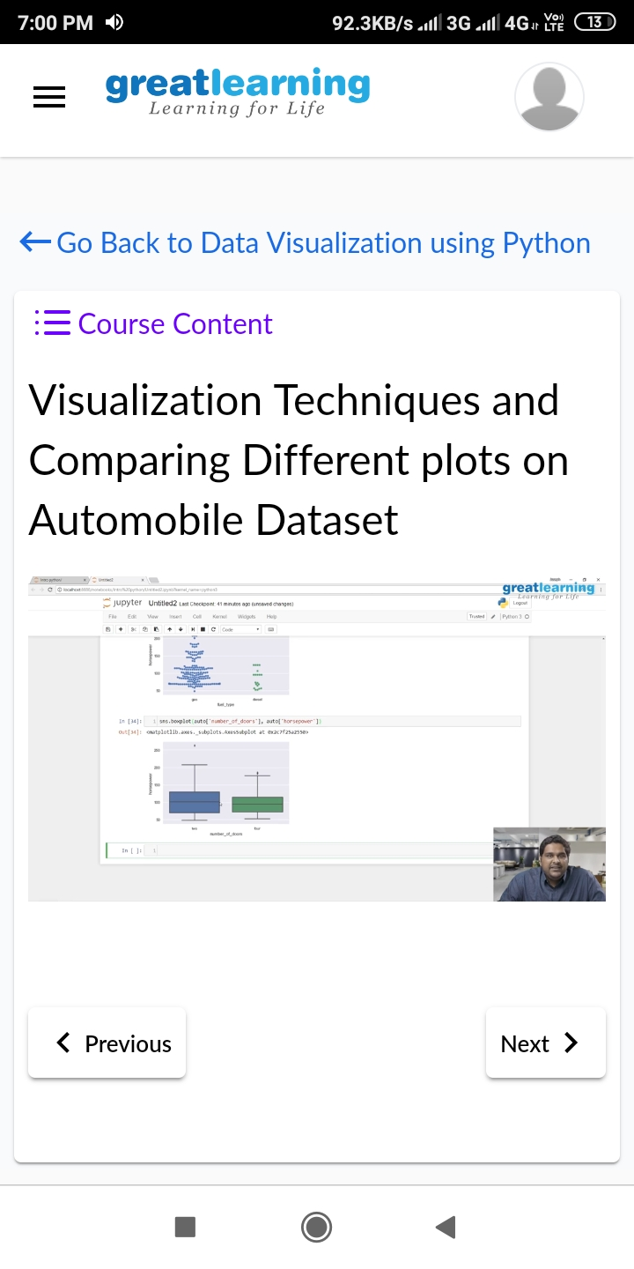

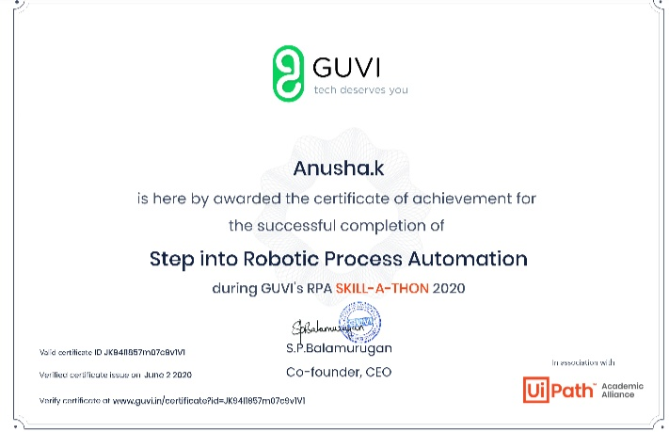

**CODING CHALLENGES DETAILS**:

**Problem statement 1:** Write a code segment in java to swap two numbers using call by object reference.

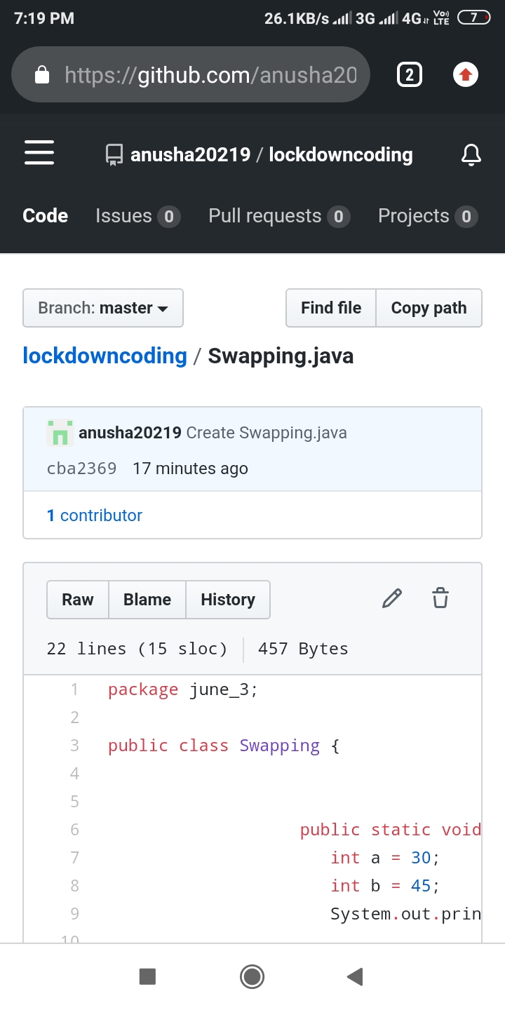

**Problem statement 2 :** Write a Java program to find Last Digit of a^b (a to the power b) for Large Numbers.

